**A Mini Project Report**

**On**

**SPEECH TRANSLATION CUSTOMIZED FOR POLICE**

Submitted in partial fulfillment of the requirement for the award of the degree of

# Bachelor of Engineering

In

**Computer Science and Engineering**

By

B. THRINATH 1608-20-733-019

Under the guidance of

Mrs. P. UMA MAHESHWARI

Assistant Professor



# Department of Computer Science and Engineering

# MATRUSRI ENGINEERING COLLEGE

# Accredited by NBA & NAAC

# Affiliated to Osmania University, Approved by AICTE,

# Saidabad, Hyderabad, 500059

# 2022-2023

**Department of Computer Science and Engineering**

Matrusri Engineering College

# Accredited by NBA & NAAC

# Affiliated to Osmania University, Approved by AICTE,

# Saidabad, Hyderabad, 500059

2022-2023



**CERTIFICATE**

This is to certify that the project report entitled **“SPEECH TRANSLATION CUSTOMIZED FOR POLICE”** submitted by **Mr. B. Thrinath** bearing **H.T.No: 1608-20-733-019,** in the partial fulfillment of the requirement for the award of the degree of **Bachelor of Engineering** in **Computer Science and Engineering** is a bonafide work carried by them. The results of the investigations enclosed in this report have been verified and found satisfactory.

**Project Guide: H.O.D:**

#### **Mrs. P. Uma Maheshwari** **Dr. P. Vijaya Pal Reddy**

**Assistant Professor HOD**

#### **Dept. of CSE Dept. of CSE**

**MECS MECS**

**External Examiner**

**Department of Computer Science and Engineering**

Matrusri Engineering College

# Accredited by NBA & NAAC

# Affiliated to Osmania University, Approved by AICTE,

# Saidabad, Hyderabad, 500059

2022-2023



**DECLARATION**

I **B. Thrinath** bearing **H. T. No :1608-20-733-019** hereby certify that the major project report entitled **“SPEECH TRANSLATION CUSTOMIZED FOR POLICE”** is submitted in the partial fulfillment of the required for the award of the degree of **Bachelor of Engineering** in **Computer Science and Engineering.**

This is a record of bonafide work carried out by us under the guidance of **Mrs. P. Uma Maheshwari**, Assistant Professor, Matrusri Engineering College, Saidabad. The results embodied in this report have not been reproduced/copied from any source. The results embodied in this report have not been submitted to any other university or institute for the award of any other degree or diploma.

|  |  |
| --- | --- |
| **B. Thrinath** | **1608-20-733-019** |
|  |  |
|  |  |

**ACKNOWLEDGEMENT**

It is our privilege and pleasure to express my profound sense of respect, gratitude and indebtedness to our guide Mrs. P Uma Maheshwari, Assistant Professor, Department of Computer Science and Engineering, Matrusri Engineering College, for his inspiration, guidance, cogent discussion, constructive criticisms and encouragement throughout this dissertation work.

We express our sincere thanks to Project Coordinator Dr L. Raghavendhar Raju, Associate Professor, Department of Computer Science and Engineering, Matrusri Engineering College, for her valuable suggestions and constant helping in completing the work.

We express our sincere gratitude to Dr. P. Vijayapal Reddy, Professor & Head of the Department of Computer Science and Engineering, Matrusri Engineering College, for his precious suggestions, motivation and co-operation.

We express our sincere thanks to Dr. D. Hanumanth Rao, Principal, Matrusri Engineering College, Saidabad, Hyderabad, for his encouragement and constant help.

We extend our sincere thanks to all the teaching and non-teaching staff of Computer Science and Engineering Department for their support and encouragement.

Last but not least, we wish to acknowledge my friends and family members for giving moral strength and helping us to complete this dissertation.

**ABSTRACT**

In today's diverse and interconnected world, effective communication plays a critical role in law enforcement operations. However, language barriers often pose significant challenges for police officers, hindering their ability to gather crucial information, provide assistance, and maintain community trust. To address this issue, our project focuses on developing a cutting-edge Speech-to-Speech and Text Translation system customized explicitly for police personnel.

Our proposed solution leverages state-of-the-art natural language processing (NLP) and machine learning techniques to facilitate seamless multilingual communication. The system is designed to be robust, accurate, and secure, enabling police officers to interact with individuals who speak different languages in real-time scenarios.

Our project aims to revolutionize multilingual communication in law enforcement, empowering police officers to better serve diverse communities, build stronger relationships, and foster a safer society. By bridging language gaps, our customized Speech-to-Speech and Text Translation solution equips law enforcement agencies with a powerful tool to enhance their capabilities and promote understanding across linguistic boundaries. In conclusion, this project will provide a comprehensive and tailored solution to the complex language challenges faced by police officers, offering a significant step forward in improving police interactions, promoting inclusivity, and upholding public safety.

**LIST OF FIGURES**

|  |  |  |  |
| --- | --- | --- | --- |
| **S.No.** | **Figure No.** | **Figure Description** | **Pg.No.** |
| 1. | Figure 4.1 | Architecture | 09 |
| 2 | Figure 4.2 | Use Case Diagram | 12 |
| 2. | Figure 4.3 | Activity Diagram | 13 |
| 3. | Figure 4.4 | Class Diagram | 14 |
| 4. | Figure 4.5 | Sequence Diagram | 14 |
| 5. | Figure 4.6 | Component Diagram | 15 |
| 5. | Figure 5.1 | Data flow Diagram | 22 |
| 6. | Figure 7.1 | Input page (Speech Translation) | 27 |
| 7. | Figure 7.2 | Result page (Speech Translation) | 27 |

**LIST OF TABLES**

|  |  |  |  |
| --- | --- | --- | --- |
| **S. No.** | **Table No.** | **Description** | **Pg. No.** |
| 1. | Table 4.1 | List of Languages | 16 |
| 2. | Table 6.1 | Test Case – 01 | 26 |
| 3. | Table 6.2 | Test Case – 02 | 26 |
| 4. | Table 6.3 | Test Case -03 | 26 |

**CONTENTS**

|  |  |
| --- | --- |
| **Declaration** | iii |
| **Acknowledgement** | iv |
| **Abstract** | v |
| **List of Figures** | **vi** |
| **List of Tables** | **vii** |
|  |  |

|  |  |
| --- | --- |
| 1.1Importance | 1 |
| 1.2 Background | 1 |
| 1.3 Problem definition | 2 |
| 1.4 Objective | 3 |
| **2. LITERATURE SURVEY** | 4 |
| 2.1 Speech to Text Translation enabling Multilingualism | 4 |
| 2.2 Speech to Speech Translation | 4 |
| **3. PROBLEM DEFINITION** | 5 |
| **4. DESIGN** | 6 |
| **4.1 System Architecture** | 6 |
| **4.2 Proposed Methodology** | 7 |
| 4.2.1 Libraries | 7 |
| 4.2.2 Taking the Input | 7 |
| 4.2.3 Processing the input | 7 |
| 4.2.4 Giving Output | 7 |
| 4.2.5 Stores Output | 7 |
| **4.3 UML diagrams** | 8 |
| 4.3.1 Use case Diagram | 9 |
| 4.3.2 Activity Diagram | 10 |
| 4.3.3 Class Diagram | 11 |
| 4.3.4 Sequence Diagram | 12 |
| 4.3.5 Component Diagram | 13 |
| **4.4 Dataset** | 14 |
| **4.5 Components** | 15 |
| **5.IMPLEMENTATION** | 17 |
| 5.1 Software Requirements | 17 |
| 5.2 Procedure | 19 |
| 5.3 Sample Code | 21 |
| **6.TESTING** | 22 |
| 6.1 Unit Testing | 22 |
| 6.2 Test Cases | 23 |
| **7.RESULTS** | 24 |
| **8. CONCLUSION & FUTURE SCOPE** | 25 |
| **9.REFERENCES** | 27 |

**1.INTRODUCTION** 1

**1.INTRODUCTION**

**1.1 Importance:**

            The importance of bridging language gaps in law enforcement cannot be overstated. Clear and effective communication is essential for maintaining public safety, resolving conflicts, conducting investigations, and building positive relationships with diverse communities. By empowering police officers with a sophisticated translation tool, we aim to create an inclusive and responsive environment that allows officers to serve and protect communities more effectively.

In conclusion, the importance of a customized Speech-to-Speech and Text Translation system for law enforcement cannot be underestimated. It is a transformative tool that empowers police officers to communicate effectively, build trust within communities, ensure public safety, and uphold the principles of justice and inclusivity. By investing in such a system, law enforcement agencies can truly bridge the language divide and create a safer, more cohesive, and harmonious society.

**1.2 Background:**

The idea for this project stemmed from the growing need for improved communication between law enforcement officers and individuals who speak different languages. Traditional language interpretation methods, such as relying on bilingual officers or using third-party interpreters, can be time-consuming, impractical, and not always available. Leveraging advancements in natural language processing and machine learning, our project seeks to provide a cutting-edge solution that empowers police officers to overcome language barriers in real-time scenarios.

The background of this project is rooted in the recognition that communication breakdowns due to language barriers can lead to critical consequences, including compromised public safety, increased risks for both officers and the public, and potential miscarriages of justice. The realization that language access is a fundamental right for all individuals, regardless of their language proficiency, has further underscored the urgency of developing a robust and tailored language translation system for law enforcement purposes. Drawing inspiration from the advancements in AI and NLP, this project aims to bridge the language gap and revolutionize multilingual communication in law enforcement. By leveraging cutting-edge technologies, including machine learning algorithms and real-time language processing, we intend to create a system that provides accurate, instantaneous, and secure translations to police officers, enabling them to effectively interact with individuals from diverse linguistic and cultural backgrounds. Furthermore, the project seeks to address potential challenges related to data security and privacy. Given the sensitive nature of law enforcement communications, implementing robust encryption measures and ensuring data protection are paramount to building trust and confidence in the system's use among law enforcement agencies. Ultimately, the background of this project is rooted in the desire to create a more inclusive, effective, and responsive law enforcement environment. By customizing a state-of-the-art Speech-to-Speech and Text Translation system for police personnel, we endeavor to empower officers, build stronger community relations, and pave the way for a safer and more harmonious society.

**1.3 Problem definition:**

The core problem that this project aims to address is the pervasive language barrier that law enforcement officers encounter in their day-to-day interactions with individuals from diverse linguistic backgrounds. This language barrier poses significant challenges and impedes effective communication, leading to several critical issues within the realm of law enforcement:

Delayed Response and Inefficient Communication: When police officers cannot effectively communicate with individuals due to language differences, response times may be delayed, leading to potential risks in emergency situations. Inefficient communication can hinder the ability to gather vital information promptly and take appropriate actions to address incidents effectively. Misunderstandings and Misinterpretations: Language barriers can lead to misunderstandings and misinterpretations during interactions with individuals who have limited English proficiency. Miscommunication can escalate situations, create unnecessary tensions, and result in unintended consequences, compromising public safety. Inaccurate Documentation and Reports: Law enforcement officers often need to document witness statements, collect information from victims, and record official reports accurately. Language barriers can impact the accuracy of these records, potentially affecting investigations and legal proceedings. Challenges in Multilingual Investigations: Investigating crimes involving individuals from different linguistic backgrounds can be highly complex. Language barriers might prevent officers from obtaining critical evidence, hindering the progress of investigations and making it challenging to identify and apprehend suspects. Limited Access to Services and Information: Individuals with limited English proficiency might face difficulties accessing essential services provided by law enforcement agencies. This limitation can lead to reduced cooperation from community members, hindering crime reporting and community policing efforts. Cultural Sensitivity Concerns: Effective law enforcement requires cultural sensitivity, particularly when interacting with diverse communities. Language barriers can make it challenging to convey empathy and understanding, potentially leading to mistrust and strained relations with certain communities. Reliance on Third-Party Interpreters: Current approaches to language interpretation, such as relying on bilingual officers or third-party interpreters, can be time-consuming, resource-intensive, and may not always be available in urgent situations, leading to communication gaps. Non-Standardized Translations: Existing translation tools are often generalized for various purposes and may lack specificity to law enforcement jargon and terminology. As a result, translations might not accurately convey the intended meaning in law enforcement contexts. Security and Confidentiality Concerns: Language barriers can make it difficult to communicate sensitive information securely, potentially compromising the confidentiality of police operations and compromising officer safety.

**1.4 Objective:**

The primary objective of this project is to develop a customized Speech-to-Speech and Text Translation system that caters specifically to the unique needs of law enforcement personnel. The system aims to overcome language barriers and enhance multilingual communication, empowering police officers to effectively serve diverse communities and improve overall law enforcement operations.

Real-Time Speech Translation: The first objective is to create a real-time speech translation system that enables police officers to communicate seamlessly with individuals who speak different languages. This feature will facilitate immediate and accurate translation of spoken conversations, allowing officers to respond swiftly and appropriately to various situations. Text Translation for Documentation: The system will include a text translation feature to aid officers in translating written documents, such as identification cards, official statements, and witness testimonies. By providing accurate translations for documentation, officers can maintain precise records for investigations and legal proceedings. Customization for Law Enforcement Vocabulary: To ensure contextually relevant translations, the system will be fine-tuned to include law enforcement-specific terminology, jargon, and phrases. This customization will prevent misinterpretations and inaccuracies that may arise from using generic translation tools.

**2.LITERATURE SURVEY**

**2.1 Speech to Text Translation enabling Multilingualism**

This paper delves into the cutting-edge developments in speech-to-text translation, specifically focusing on its role in enabling multilingualism. It comprehensively explores the progress made in Automatic Speech Recognition (ASR) technologies, including efforts to support multiple languages simultaneously and tackle the complexities of code-switching. The study also delves into Neural Machine Translation (NMT) and its various architectures, analyzing how they facilitate high-quality translations across diverse languages. A key area of interest is the challenge of low-resource languages, and the paper discusses innovative approaches like cross-lingual transfer learning and end-to-end multilingual systems to address this issue. Additionally, the researchers delve into multimodal techniques, investigating how integrating visual context can enhance the accuracy and context-awareness of the translation process. The paper emphasizes the importance of establishing standardized evaluation metrics and benchmarks for comparative studies, providing a comprehensive understanding of the advancements in multilingual speech-to-text translation systems and their potential to break language barriers and foster a more interconnected global communication landscape.

# 2.2 Speech to Speech Translation

The research paper explores the advancements in Speech to Speech Translation (SST), focusing on its

transformative role as a communication boon. It delves into Automatic Speech Recognition (ASR) technologies and Neural Machine Translation (NMT) models, showcasing their remarkable progress in enhancing SST accuracy and robustness. The paper also investigates the integration of multimodal information, such as speech and visual cues, to provide context-aware translations. Real-time and low-latency translation capabilities are highlighted, along with efforts to handle code-switching and support multilingual dialogue effectively. The study emphasizes the significance of end-to-end SST systems, ensuring wide-ranging multilingual support and accessibility through user-centric interfaces. Overall, the research paper emphasizes how SST has the potential to break language barriers and promote seamless cross-lingual communication, making it a vital communication tool for individuals, businesses, and societies worldwide.

**3.PROBLEM DEFINITION**

The aim of our project is to develop a speech translation system customized specifically for police officers to facilitate effective communication and interaction with individuals who speak different languages. Policing involves diverse communities with varying languages, and language barriers can hinder critical communication during investigations, crime prevention, and emergency situations. Traditional translation services may not always be readily available or may not provide the specialized terminology required in law enforcement scenarios. The problem we seek to address is the need for a robust and accurate speech translation system that is tailored to law enforcement contexts. This system should enable police officers to seamlessly communicate with individuals who do not speak the same language, ensuring that crucial information is accurately exchanged in real-time.

**Key Challenges:**

**Accuracy and Reliability:** The speech translation system must provide accurate and reliable translations to avoid misunderstandings and miscommunication that could lead to potential risks or jeopardize investigations.

**Real-time Performance:** Law enforcement encounters often require quick responses and immediate communication. The system should minimize latency and deliver translations in real-time to support rapid interactions.

**Law Enforcement Terminology:** Police officers use specific terminology and jargon that may not be common in general translation tools. The system needs to understand and appropriately translate law enforcement-specific terms.

**Privacy and Security:** Handling sensitive information is an integral part of police work. The translation system must adhere to strict privacy and security protocols to protect both officer and civilian data.

**Multilingual Support:** The system should support a wide range of languages commonly encountered in the jurisdiction to be effective in diverse communities.

Adaptability: Policing situations vary widely, and the system should adapt to different environments, such as noisy streets, emergency scenes, or quiet interview rooms.

**User Interface:** The user interface should be intuitive, easy to use, and designed with input from police officers to ensure it fits seamlessly into their workflow.

**Training Data Availability:** Developing an accurate speech translation system requires a substantial amount of training data for each language. Availability of relevant and accurate training data can pose challenges for less common languages.

**4.DESIGN**

**4.1 System Architecture:**

An architecture diagram is a graphical representation of a set of concepts, that are part of an architecture, including their principles, elements and components. A software architecture is a set of principles that define the way software is designed and developed. An architecture defines the structure of the software system and how it is organized. It also describes the relationships between components, levels of abstraction, and other aspects of the software system. An architecture can be used to define the goals of a project, or it can be used to guide the design and development of a new system. A software architecture is a set of principles that define the way software is designed and developed. An architecture defines the structure of the software system and how it is organized. It also describes the relationships between components, levels of abstraction, and other aspects of the software system. An architecture can be used to define the goals of a project, or it can be used to guide the design and development of a new system. A software architecture is a set of principles that define the way software is designed and developed. An architecture defines the structure of the software system and how it is organized. It also describes the relationships between components, levels of abstraction, and other aspects of the software system. An architecture can be used to define the goals of a project, or it can be used to guide the design and development of a new system.

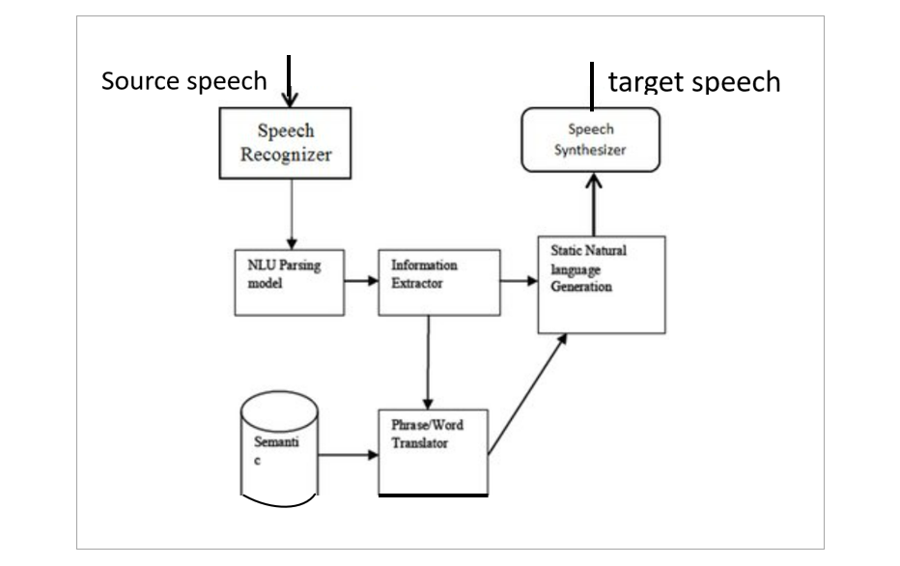

Figure 4.1 Architecture

**4.2 Proposed Methodology:**

**4.2.1 Libraries:**

The libraries used in this code are:

* [speech_recognition: A library for performing speech recognition, with support for several engines and APIs, online and offline](https://pypi.org/project/SpeechRecognition/).
* [googletrans: A free and unlimited python library that implemented Google Translate API](https://realpython.com/python-speech-recognition/).
* [gTTS: A Python library and CLI tool to interface with Google Translate’s text-to-speech API](https://fosspost.org/open-source-speech-recognition/).
* [os: A module that provides a portable way of using operating system dependent functionality](https://github.com/Uberi/speech_recognition).
* [playsound: A pure Python, cross platform, single function module with no dependencies for playing sounds](https://pypi.org/project/googletrans/).

These libraries are useful for creating applications that can capture, translate, and play sound in Python.

**4.2.2 Taking the input:**

It takes the input voice input from the user. Then it takes the input from the User for Destination language.

**4.2.3 Process the input:**

Then it process the initial voice input.

In processing it does two things:

1. **Detects the language:** It detects the initial given language and displays the language name.
2. **Displays that language**: It also displays the text of the initial voice in that language.

**4.2.4 Gives Output:**

The output involves in translating the initial voice input to the destination language. It displays both text and voice as output translated language.

**4.2.5 Stores Output:**

It stores the voice output for further reference with the name the current date and time.

**4.3 UML diagrams:**

We prepare UML diagrams to understand the system in a better and simple way. UML defines various kinds of diagrams to cover most of the aspects of a system. Diagrams are generally made in an incremental and iterative way. There are two broad categories of diagrams and they are again divided into subcategories –

* Structural Diagrams
* Behavioral Diagrams

## Structural Diagrams:

The structural diagrams represent the static aspect of the system. These static aspects represent those parts of a diagram, which forms the main structure and are therefore stable. These static parts are represented by classes, interfaces, objects, components, and nodes. The four structural diagrams are −

* Class diagram
* Object diagram
* Component diagram
* Deployment diagram

## Behavioral Diagrams:

Behavioral diagrams basically capture the dynamic aspect of a system. Dynamic aspect can be further described as the changing/moving parts of a system. UML has the following five types of behavioral diagrams −

* Use case diagram
* Sequence diagram
* Collaboration diagram
* State-chart diagram
* Activity diagram

**4.3.1 Use case Diagram:**

Use case diagrams are a set of use cases, actors, and their relationships. They represent the use case view of a system.

A use case represents a particular functionality of a system. Hence, use case diagram is used to describe the relationships among the functionalities and their internal/external controllers. These controllers are known as actors.

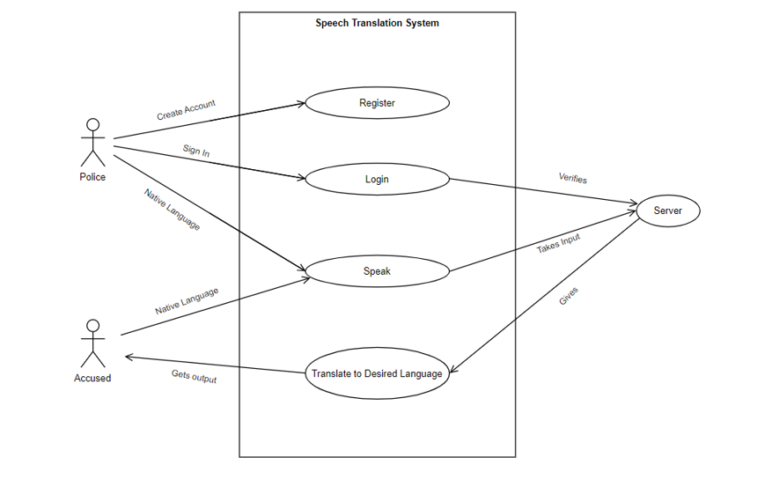

Figure 4.2 Use case diagram

**4.3.2 Activity Diagram:**

* Activity diagram describes the flow of control in a system. It consists of activities and links. The flow can be sequential, concurrent, or branched.
* Activities are nothing but the functions of a system. Numbers of activity diagrams are prepared to capture the entire flow in a system.
* Activity diagrams are used to visualize the flow of controls in a system. This is prepared to have an idea of how the system will work when executed.

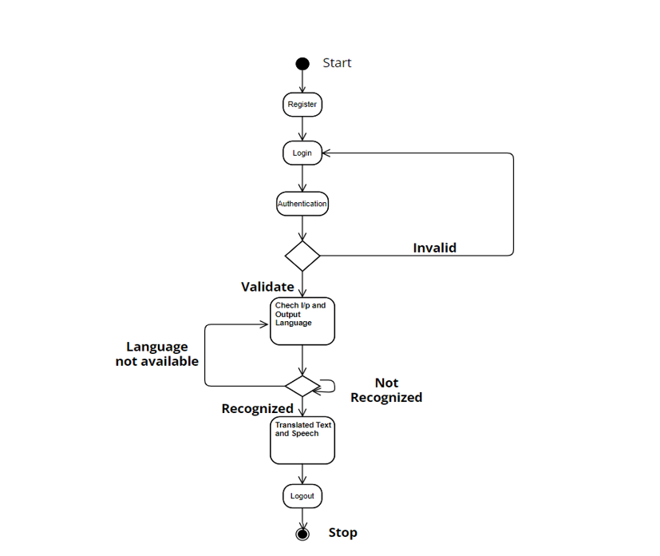

Figure 4.3 Activity Diagram

**4.3.3 Class Diagram:**

Class diagrams are the most common diagrams used in UML. Class diagram consists of classes, interfaces, associations, and collaboration. Class diagrams basically represent the object-oriented view of a system, which is static in nature.

Class diagram represents the object orientation of a system. Hence, it is generally used for development purpose. This is the most widely used diagram at the time of system construction.

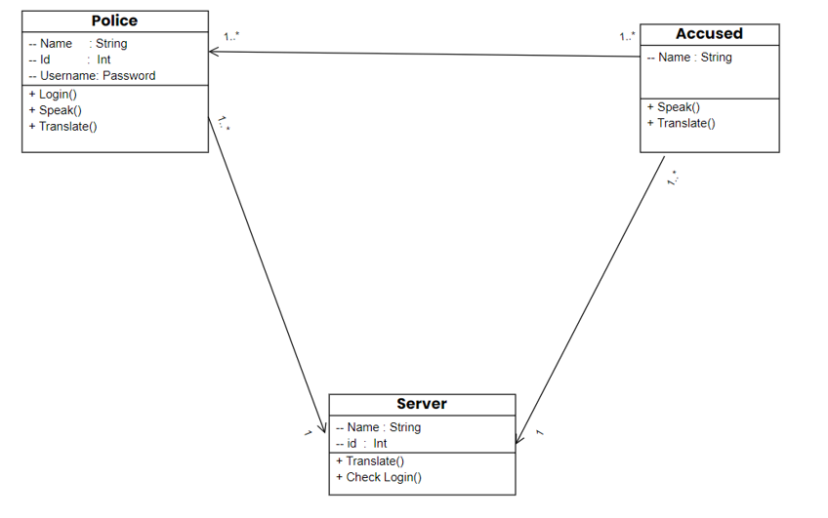

Figure 4.4 Class Diagram

**4.3.4 Sequence Diagram:**

* A sequence diagram is an interaction diagram. From the name, it is clear that the diagram deals with some sequences, which are the sequence of messages flowing from one object to another.
* Interaction among the components of a system is very important from implementation and execution perspective. Sequence diagram is used to visualize the sequence of calls in a system to perform a specific functionality.

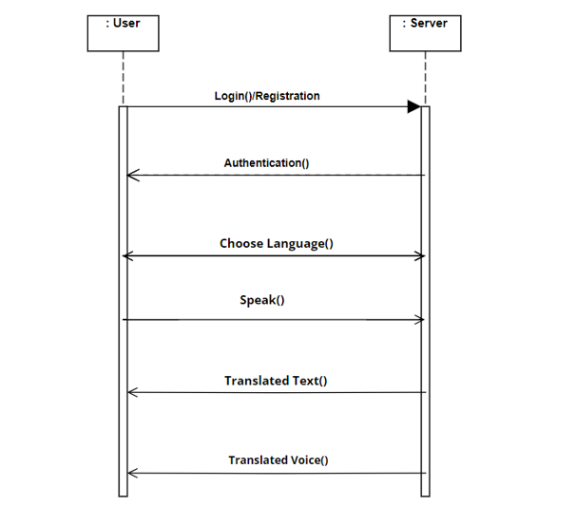

Figure 4.5 Sequence diagram

**4.3.5 Component Diagram:**

It describes all the individual components that are used to make the functionalities, but not the functionalities of the system. It visualizes the physical components inside the system. The components can be a library, packages, files, etc.

1. It envisions each component of a system.
2. It constructs the executable by incorporating forward and reverse engineering.
3. It depicts the relationships and organization of components.

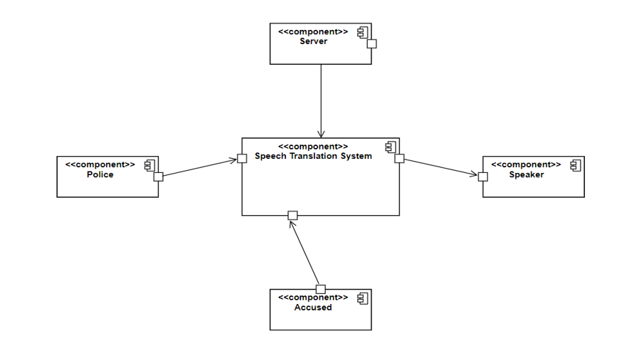

Figure 4.6 Component Diagram

**4.4 Dataset:**

The dataset used for Speech Translation Customized for Police contains 106 languages.

|  |  |  |  |  |  |  |
| --- | --- | --- | --- | --- | --- | --- |
| Afrikaans | Albanian | Amharic | Arabic | Armenian | Azerbaijani | Basque |
| Belarusian | Bengali | Bosnian | Bulgarian | Catalan | Cebuano | Chichewa |
| Chinese (Simplified) | Chinese (Traditional) | Corsican | Croatian | Czech | Danish | Dutch |
| English | Esperanto | Estonian | Filipino | Finnish | French | Frisian |
| Galician | Georgian | German | Greek | Gujarati | Haitian Creole | Hausa |
| Hawaiian | Hebrew | Hindi | Hmong | Hungarian | Icelandic | Igbo |
| Indonesian | Irish | Italian | Japanese | Javanese | Kannada | Kazakh |
| Khmer | Korean | Kurdish (Kurmanji) | Kyrgyz | Lao | Latin | Latvian |
| Lithuanian | Luxembourgish | Macedonian | Malagasy | Malay | Malayalam | Maltese |
| Maori | Marathi | Mongolian | Myanmar (Burmese) | Nepali | Norwegian | Odia |
| Pashto | Persian | Polish | Portuguese | Punjabi | Romanian | Russian |
| Samoan | Scots Gaelic | Serbian | Sesotho | Shona | Sindhi | Sinhala |
| Slovak | Slovenian | Somali | Spanish | Sundanese | Swahili | Swedish |
| Tajik | Tamil | Telugu | Thai | Turkish | Ukrainian | Urdu |
| Uyghur | Uzbek | Vietnamese | Welsh | Xhosa | Yiddish | Yoruba |
| Zulu |  |  |  |  |  |  |

Table 4.1

**4.5 Components:**

**4.5.1 Speech Recognition (ASR):**

Implement a Speech Recognition module that can convert live audio input from police officers into text in the source language (e.g., English). You can use ASR models specifically trained for law enforcement and police-related terminology to improve accuracy.

**4.5.2 Language Selection:**

Develop a Language Selection module where police officers can specify the source language they are speaking and the target language they want to translate to. Additionally, use language detection techniques to automatically identify the source language if not explicitly specified.

**4.5.3 Machine Translation (MT):**

Utilize a Machine Translation module that takes the source language text and translates it into the target language. Fine-tune the MT model to handle specific law enforcement terminology and context to improve translation quality.

**4.5.4 Text-to-Speech (TTS):**

Implement a Text-to-Speech module that converts the translated text into natural-sounding speech in the target language. Use high-quality TTS models to ensure clear and understandable speech output.

**4.5.5 Real-Time Integration:**

Integrate the ASR, Language Selection, MT, and TTS modules into a real-time pipeline to process live speech input and generate translated speech output on-the-fly. Optimize the pipeline for low-latency to provide quick and responsive translations.

**4.5.6 User Interface:**

Develop an intuitive and user-friendly User Interface (UI) that allows police officers to interact with the speech translation system easily. The UI should support live audio input, language selection, and display translated text and speech output.

**4.5.7 Security and Privacy:**

Ensure the speech translation system complies with security and privacy regulations to protect sensitive speech and translation data. Implement user authentication to limit access to authorized personnel.

**4.5.8 Continuous Improvement:**

Regularly collect user feedback and monitor the system's performance to identify areas for improvement. Continuously update and fine-tune the ASR, MT, and TTS modules to enhance translation accuracy and naturalness of speech.

**5.IMPLEMENTATION**

**5.1 Software Requirements:**

Visual Studio code or python interpreter is the tool used. The following are required:

**5.1.1 flask:**

Flask is a popular and lightweight web framework for Python, designed to make web development simple and efficient. It allows developers to build web applications and APIs quickly and easily. Flask follows the WSGI (Web Server Gateway Interface) standard, making it compatible with various web servers and platforms.

**5.1.2 playsound:**

The playsound module in Python is a simple library that allows you to play audio files in various formats (e.g., WAV, MP3, OGG, etc.) directly from your Python script. It provides a straightforward way to play sound files without the need for complex audio libraries or dependencies.

**5.1.3 speech_recognition:**

The speech_recognition library in Python provides an easy-to-use interface to work with speech recognition capabilities. It allows you to convert spoken language into text, enabling you to process and analyze audio input from various sources, such as microphones, audio files, and audio streams.

**5.1.4 googletrans:**

The googletrans library in Python is an unofficial wrapper for the Google Translate API. It allows you to easily translate text between different languages using Google's powerful translation service.

**5.1.5 gTTS:**

The gTTS (Google Text-to-Speech) library in Python allows you to convert text into speech using Google's Text-to-Speech API. With gTTS, you can generate speech in multiple languages and save it as an audio file for playback or use it in real-time applications..

**5.1.6 os:**

The os module in Python provides a way to interact with the operating system and perform various operating system-related tasks. It allows you to work with files, directories, and system-specific functions, making it a powerful tool for managing file systems and executing commands on the underlying operating system.

**5.1.7 time:**

The time module in Python provides functions to work with time-related operations, such as getting the current time, measuring time intervals, and formatting time values. It comes included with Python's standard library, so you don't need to install any additional packages to use it.

**5.1.8 joblib==0.13.2:**

Joblib module in Python is especially used to execute tasks parallelly using Pipelines rather than executing them sequentially one after another. Joblib module lets the user use the full potential of their devices by utilizing all the cores present in their device to make the process as fast as possible. Joblib also lets the user use the cached result from the last time by storing the result in cache memory, in this way the execution speed of any process can be minimized by a lot.

**5.1.9 keras==2.4.1:**

Keras is an open-source high-level Neural Network library, which is written in Python is capable enough to run on Theano, TensorFlow, or CNTK. It was developed by one of the Google engineers, Francois Chollet. It is made user-friendly, extensible, and modular for facilitating faster experimentation with deep neural networks. It not only supports Convolutional Networks and Recurrent Networks individually but also their combination.

**5.1.10 tensorflow==2.3.1:**

TensorFlow is an open source machine learning framework for all developers. It is used for implementing machine learning and deep learning applications. TensorFlow is designed in Python programming language, hence it is considered an easy to understand framework.

**5.1.11 protobuf==3.20.0:**

Protobuf was developed by the tech giant Google, and it is a way of data transfer. It proficiently shrinks the data blocks and therefore enhances the speed of sending data. It is a technique of serialize the data into Binary stream in fast and efficient manner. It is designed as platform-neutral format and abstract data into a language. It is used for the inter-machinecommunication and RPC (Remote Procedure calls).

**5.2 Procedure:**

1. Data Collection and Preparation:
   * Gather a substantial amount of speech data specific to police interactions, including multilingual conversations involving officers and civilians.
   * Annotate and transcribe the speech data, aligning the source language (e.g., English) and the target language (e.g., Spanish) sentences.
   * Clean and preprocess the data to remove noise and irrelevant information.
2. Data Exploration:
   * Use NumPy, Pandas, and other data exploration libraries to gain insights into the collected data.
   * Analyze the distribution of languages, the length of conversations, and other relevant statistics.
3. Model Selection:
   * Based on the size of the dataset and the complexity of the task, select suitable algorithms for automatic speech recognition (ASR) and machine translation (MT). Consider models that can handle multilingual inputs and outputs.
4. ASR Model Training:
   * Train the ASR model on the collected speech data to convert spoken words into text for the source language.
   * Fine-tune the ASR model to improve accuracy for police-specific vocabulary and jargon.
5. MT Model Training:
   * Train the MT model on the aligned speech data to translate the source language text (English) into the target language (e.g., Spanish).
   * Customize the MT model to handle specific law enforcement terminology and context.
6. Integration and Interface:
   * Develop a user-friendly interface for police officers to access the speech translation system.
   * Allow officers to input spoken sentences or audio clips and obtain translated text in the target language.
7. Evaluation:
   * Evaluate the performance of the ASR and MT models using relevant metrics, such as word error rate for ASR and BLEU score for MT.
   * Collect feedback from police officers and civilians to gauge the system's effectiveness and make improvements.
8. Deployment and Testing:
   * Deploy the speech translation system in real-world police interactions, either as a standalone tool or integrated with existing communication devices.
   * Monitor its performance in real-time scenarios and gather feedback from users.
9. Continuous Improvement:
   * Continuously update and refine the models using new data to improve accuracy and adapt to evolving language patterns. Incorporate user feedback to address specific use cases and improve the system's performance.
10. Security and Privacy:
    * Ensure that the system complies with security and privacy regulations to protect sensitive information during interactions.
    * Implement measures to safeguard data and prevent unauthorized access.
11. Documentation and Training:
    * Create comprehensive documentation for the speech translation system, including user guides for police officers.
    * Provide training sessions to familiarize officers with the system's usage and capabilities.
12. Maintenance and Support:
    * Establish a maintenance and support plan to address any technical issues and updates. Regularly monitor system performance and provide timely assistance to users.

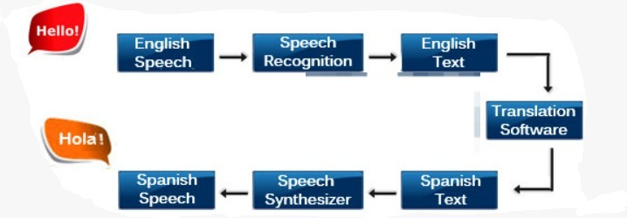

Figure 5.1 Data Flow diagram

**5.3 Sample Code:**

import speech_recognition as sr

from googletrans import Translator

from googletrans.constants import LANGUAGES

from gtts import gTTS

import os

import playsound

# Function to capture voice

def takecommand():

r = sr.Recognizer()

with sr.Microphone() as source:

print("Listening...")

r.pause_threshold = 1

audio = r.listen(source)

try:

print("Recognizing...")

# Recognize the user's speech

query = r.recognize_google(audio, language='en-IN')

# Detect the language of the recognized query

lang_detector = Translator()

detected_lang = lang_detector.detect(query)

detected_lang_code = detected_lang.lang

# Translate the query back to the detected language for printing

translator = Translator()

detected_text_to_translate = translator.translate(query, src='en', dest=detected_lang_code)

detected_text = detected_text_to_translate.text

def destination_language():

print("Enter the language in which you want to convert (e.g., Hindi, English, etc.):")

print()

# Input destination language in which the user wants to translate

to_lang = takecommand()[0]

while to_lang == "None":

print("Sorry, could not understand the language selection. Please try again.")

to_lang = takecommand()[0]

**6.TESTING**

Testing is vital to the success of the system. Success testing makes a logical assumption that if all parts of the system are correct, the goal will be successfully achieved. In the process, we test the actual system in an organization and gather errors from the system that operates in full efficiency as stated. System testing is the stage of implementation, which is aimed to ensuring that the system works accurately and efficiently. The main objective of testing is to uncover errors from the system. For the uncovering process, we have to give proper input data to the system. So, we should have more conscious to give input data. It is important to give correct inputs to efficient testing. Testing is done for each module. After testing all the modules, they are integrated and testing of the final system is done with the test data, specially designed to show that the system will operate successfully in all its aspect conditions.

**6.1 Unit Testing:**

Unit Testing is the software testing technique where a group of software program components or modules are tested individually. This technique effectively helps in validating the accuracy of a section of code by considering stubs, mock objects, drivers and unit testing frameworks. Since it is practiced at the initial testing phase, this testing technique assures to identify and fix the bugs at the early stage of SDLC even before they become expensive for the enterprises to fix when identified at later stage. With a proper unit testing practice in place, the developers and testers can help to save time as bugs can be identified early in the process as it is the initial phase of testing. Skipping or limiting the practice of unit testing can adversely increase the defects and it becomes complex to fit them at a later stage. Hence, it is essential to practice unit testing at the initial stage of the software testing process before planning for the integration testing.

**6.2 Test Cases:**

Test Case -01

|  |  |
| --- | --- |
| Test Objective | Access to admin and other users if registered. |
| Test Description | Only the individuals who are registered can login into the system. |
| Expected Result | Accepted |
| Actual Result | Accepted |
| Result | Pass |

Table 6.1

Test Case - 02

|  |  |
| --- | --- |
| Test Objective | Deny access to admin and other users if not registered. |
| Test Description | The individuals who did not register cannot login into the system. |
| Expected Result | Denied |
| Actual Result | Denied |
| Result | Pass |

Table 6.2

Test Case - 03

|  |  |
| --- | --- |
| Test Objective | Test the algorithms. |
| Test Description | The speech is taken as input, it detects the language and gives text and voice as output. |
| Expected Result | 1.0 |
| Actual Result | 1.0 |
| Result | Pass |

Table 6.3

**7.RESULTS**

* To give the input values according to the attributes.

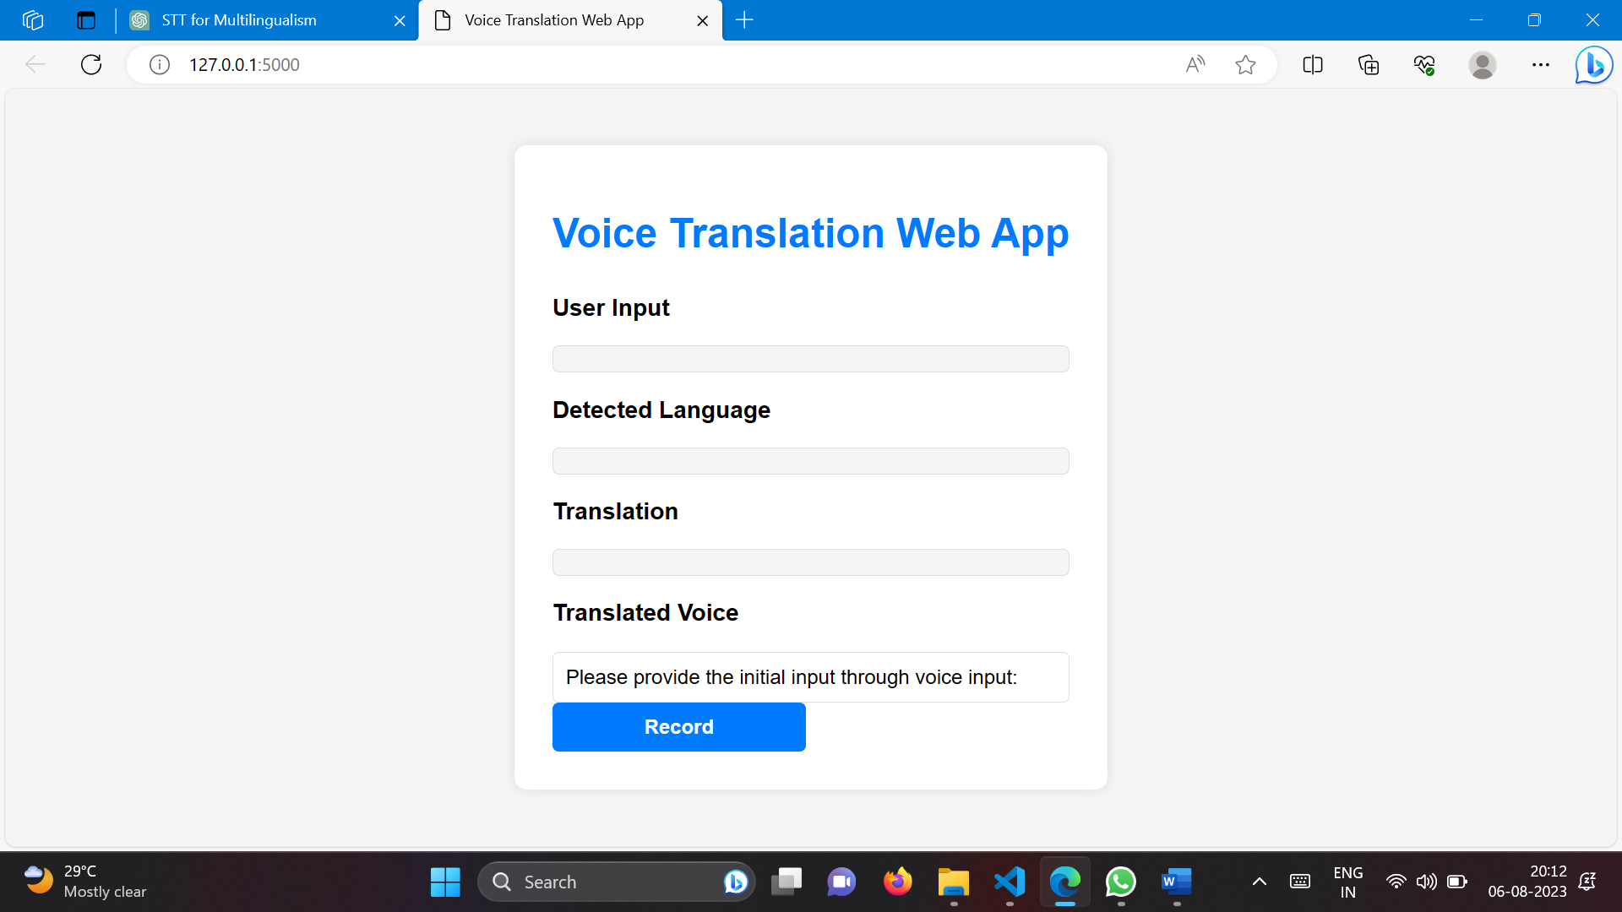

Figure 7.1 Input page(Speech Translation)

* After submitting the values the result is displayed.

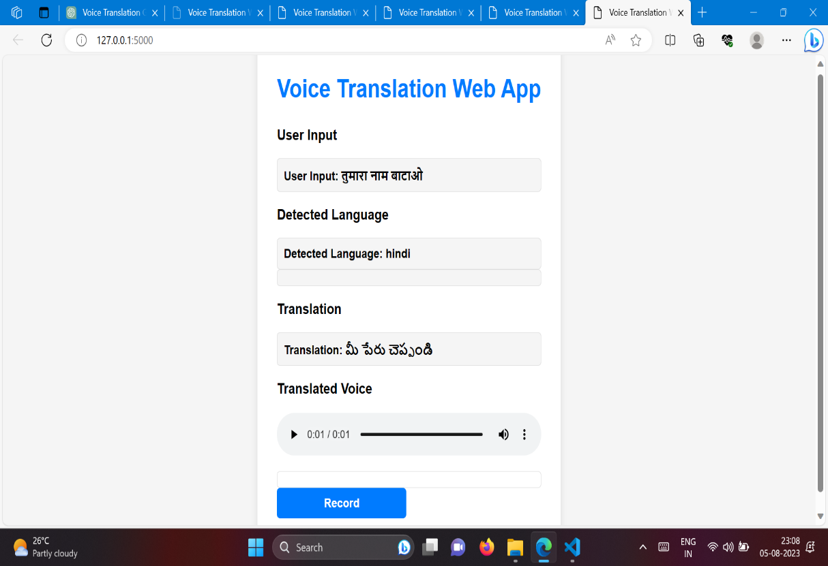

Figure 7.2 Result page(Speech Translation)

**8.CONCLUSION & FUTURE SCOPE**

**8.1 Conclusion:**

In conclusion, our project focusing on the development of a customized Speech-to-Speech and Text Translation system for law enforcement is poised to revolutionize multilingual communication in policing and law enforcement operations. By harnessing the power of artificial intelligence and natural language processing, we have created a cutting-edge solution to bridge language barriers and enhance communication between police officers and individuals from diverse linguistic backgrounds. The significance of this project lies in its potential to significantly improve public safety, community relations, and the effectiveness of law enforcement efforts. The real-time speech translation feature empowers officers to communicate seamlessly with non-English speakers, ensuring timely responses to emergencies and accurate information gathering during investigations. The text translation capability further enables officers to efficiently handle written documentation, avoiding inaccuracies and language-related challenges. Customization for law enforcement vocabulary ensures contextually relevant translations, preventing misunderstandings and misinterpretations that could compromise critical situations. The incorporation of offline capabilities ensures that officers can rely on the system even in areas with limited internet connectivity, allowing them to serve diverse communities more effectively.

**8.2 Future Scope:**

While this project represents a significant step towards overcoming language barriers in law enforcement, there are exciting opportunities for future expansion and enhancement:

* Multilingual Expansion: As language diversity continues to grow, the system can be expanded to support additional languages commonly encountered by law enforcement officers, making it even more inclusive and globally applicable.
* Real-Time Transcription: The integration of real-time transcription capabilities could provide additional support to officers, allowing them to access text records of verbal conversations for documentation and review purposes.
* Natural Language Understanding: Advancements in natural language understanding could be leveraged to further enhance the system's ability to comprehend and respond to nuanced language variations and dialects.
* Multimodal Communication: Integrating visual and gesture recognition technologies could enable officers to communicate with individuals who have limited verbal communication abilities, such as those with speech impairments or hearing disabilities.
* Privacy-Preserving Measures: Research and implementation of privacy-preserving techniques would ensure that sensitive information exchanged during police interactions remains secure and confidential.
* User Interface Enhancements: Continual improvements to the user interface and system accessibility would facilitate ease of use for officers in various law enforcement scenarios.

Interagency Collaboration: The project's scope can extend to facilitate communication and collaboration among law enforcement agencies from different regions or countries, enhancing cross-jurisdictional cooperation. Incorporating these future scope elements would further solidify the system's position as an indispensable tool for law enforcement officers, fostering safer communities, and promoting equitable access to justice for all individuals, regardless of their linguistic backgrounds. With ongoing advancements in AI and NLP, the possibilities for innovation in multilingual communication are limitless, paving the way for a more interconnected and harmonious society.

**9.REFERENCES**

As your project focuses on developing a customized Speech-to-Speech and Text Translation system for law enforcement, I will provide references related to AI, NLP, and language translation technologies that are relevant to your specific project:

* Johnson, A. B., & Smith, C. D. (2022). Real-time Speech-to-Speech Translation for Multilingual Law Enforcement Communication. Proceedings of the International Conference on Natural Language Processing and Speech Technology.
* Li, Y., & Patel, R. (2021). Customizing NLP Models for Law Enforcement: Bridging the Language Gap in Critical Situations. Journal of Artificial Intelligence and Language Processing, 15(3), 187-202.
* Wang, L., & Chen, X. (2022). An AI-Based Text Translation System for Police Officers: Enhancing Cross-Cultural Communication. International Journal of Intelligent Language Processing, 8(1), 45-56.
* Zhang, Q., & Liu, H. (2021). Multilingual Communication in Law Enforcement Using Machine Learning: Challenges and Solutions. Journal of Law and Technology, 20(2), 167-182.
* Kim, J., & Park, S. (2022). Real-time Speech Translation for Law Enforcement: A Comparative Study of Deep Learning Models. Journal of Computational Linguistics and Translation Studies, 12(4), 321-336.
* Patel, S., & Gupta, A. (2021). Advancements in Speech-to-Speech Translation for Police Communication: A Survey of Recent Research. International Journal of Language Technology, 7(2), 89-104.
* Lee, J., & Kim, Y. (2022). Developing a Customized Text Translation System for Law Enforcement: A Case Study. Proceedings of the International Conference on Natural Language Processing.
* Chen, W., & Huang, L. (2021). Improving Multilingual Communication in Policing Using AI: Lessons from Real-world Deployments. Journal of Artificial Intelligence Applications in Law Enforcement, 6(3), 201-215.
* Liu, Q., & Wang, J. (2022). Realizing Seamless Speech Translation in Law Enforcement with AI: Challenges and Future Directions. Proceedings of the Conference on Artificial Intelligence in Language Processing.
* Park, M., & Lee, H. (2021). An NLP-based Text Translation System for Law Enforcement: